Corporate Communication
PG Sem 3
Unit 1

Definition of verbal communication
“Verbal communication refers to the use of words in delivering the intended message. The main components of verbal communication are sound, words, speaking, and language.” – Albert Mehrabian
“Verbal communication is the process of exchanging information and ideas through the use of spoken words. It involves the use of language, tone, pitch, and other elements to convey meaning and intent.” – Richard L. Daft
What is verbal communication?
Verbal communication is the use of speech to convey messages between individuals or groups. It is an essential skill for effective communication in personal and professional settings. Verbal communication involves both speaking and listening, as it requires active participation from both the sender and the receiver of the message.
The sender is the person who initiates the communication by formulating their thoughts into words and delivering them through speech. The receiver, on the other hand, listens attentively to the spoken words and interprets their meaning.
What are the characteristics of verbal communication?
Verbal communication is a vital part of human interaction, its diverse features play a crucial role in shaping effective and impactful interactions. The following are the main features of verbal communication:
1/ Interactive: Verbal communication is an interactive process that involves a sender and a receiver who engage in a dialogue or conversation.
2/ Multichannel: Verbal communication can involve multiple channels, including tone of voice, facial expressions, and body language, in addition to spoken words.
3/ Language-based: Verbal communication involves the use of language, whether it is spoken, written, or signed.
4/ Immediate: Verbal communication is often immediate and happens in real-time, allowing for instant feedback and clarification.
5/ Clarity and Fluency: Effective verbal communication emphasizes clear and consistent delivery of messages to ensure understanding.
Examples of verbal communication
In the list below, we have presented some real-life examples of verbal communication that showcase the various ways in which we use verbal words to convey messages and ideas.
1/ A business meeting where participants discuss project goals, challenges, and progress updates is a primary example of verbal communication in the workplace.
2/ A job interview is where a candidate answers questions and communicates their skills, experiences, and motivations to the interviewer.
3/ A customer service representative on a phone call, responding to a customer’s inquiry, resolving complaints, and providing solutions.
4/ A public speaker delivers a speech, inspiring and motivating the audience through the power of words and delivery.
5/ A team brainstorming session, where members collaborate and verbally express ideas, contributing to problem-solving and decision-making.
6/ A negotiation between two business partners, where they engage in verbal communication to discuss terms, reach agreements, and resolve conflicts.

What Is Interoffice Communication?
Interoffice communication refers to the exchange of information, ideas, and messages between individuals or teams within an organization. It is a vital component of effective organizational communication, as it enables employees to collaborate, share knowledge, and work together towards common goals. Interoffice communication can take many forms, including verbal, nonverbal, written, and visual communication.
The Importance of Interoffice Communication
Effective interoffice communication is essential for the success of any organization. It helps to:
- Improve collaboration and teamwork: By facilitating the exchange of ideas and information, interoffice communication enables employees to work together more effectively, leading to better outcomes and increased productivity.
- Enhance decision-making: Interoffice communication ensures that all stakeholders are informed and involved in the decision-making process, leading to more informed and effective decisions.
- Boost employee engagement: When employees feel informed and connected to the organization, they are more likely to be engaged and motivated, leading to improved job satisfaction and reduced turnover.
- Foster a positive work culture: Interoffice communication helps to create a positive and inclusive work culture, where employees feel valued and respected.

Interoffice Communication
Letter writing is still used for a lot of our communication, especially in official communication. Letters are still an important means of communication, whether it’s a cover letter for a job, a bank reminder, or a college acceptance letter. So it is necessary to understand letter writing. Here in this article, we will learn how to practice wonderful letter writing.

Letter Writing Format
Letter Writing has been deemed as one of the most useful forms of communication and is used for various reasons. There are various kinds of letters, each of which has its own form and style. Here are the general guidelines for letter writing:
- Sender’s address: To start, write the sender’s complete address in the upper left-hand corner, including your entire name, street address, city, state, and pin code.
- Dateline: The Date should be specified by skipping a line.
- Recipient’s address: Place the recipient’s entire address after skipping a line. The firm name, the recipient’s name and title, and the postal address must all be included in a letter.
- Greeting/Salutation: To put the welcome, skip one more line. This is called a salutation. In a formal letter, you should write “Dear Mr./Ms./Mrs. Last Name:” After the greeting, the colon mark should be used in informal letters, whereas informal ones demand a comma.
- Body of letter: After skipping a line you should start the body of the letter. Separate your thoughts into different paragraphs in the body of your letter so that your letter writing is presentable. Leave a blank line between paragraphs
- Subscription/ Complimentary Close: To incorporate a subscription, skip one of your final lines. “Sincerely,” “Yours faithfully,” “Regards,” or something similar can be used as a closure. Whether the letter is official or casual, a comma should always follow the word or phrase you choose to close it.
- Signature text: After Skip three lines (where your handwritten signature will be inserted) and input your entire name. On the next line of a formal letter, you should also add your job title.

Different Types of Letters
Letters can vary widely based on their purpose and audience. Some of them are Formal letters, Informal letters, Semi-Formal letters, Official letters, and Academic letters. Each type of letter follows specific conventions and formats suited to its purpose and audience. Here we have discussed the two main type of them.
Formal Letters- Also known as Business Letters, include Letters of Application, Letters to Higher Authorities, and Letters to Newspapers.
Informal Letters- Also known as Social Letters, include Friendly Letters and Notes of Invitations.
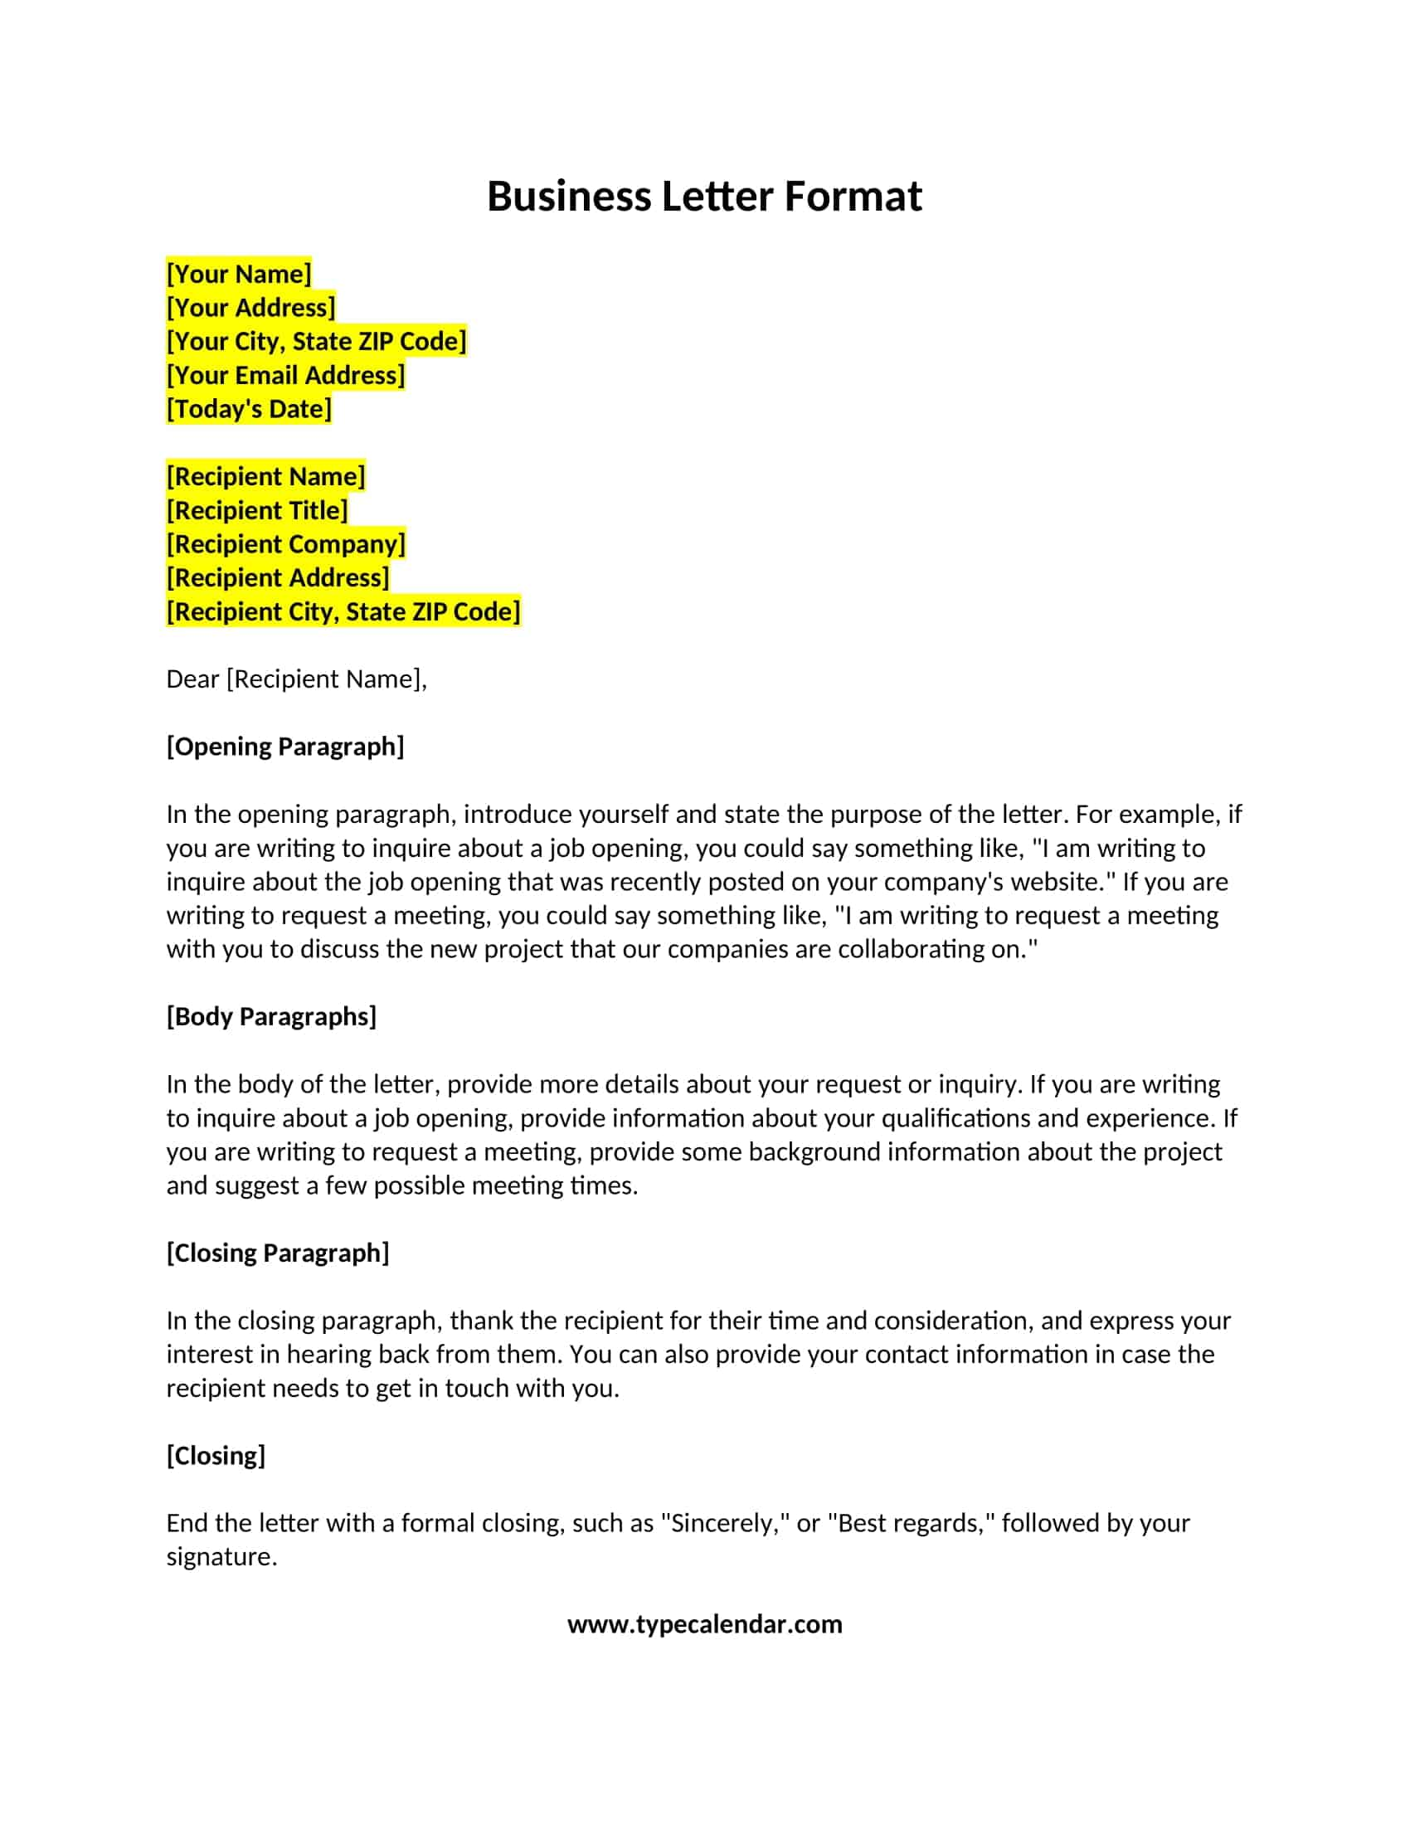

BLOCK LETTER FORMAT

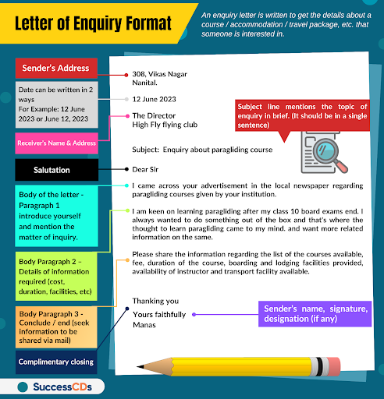

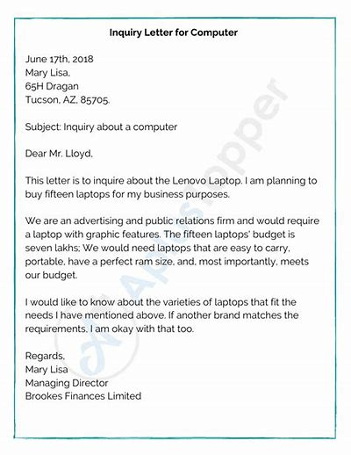

Sales Letter
What is a Sales Letter?
A sales letter is a letter written to publicise and ultimately sell a product or a service to the consumers. It is a type of business letter; meant for generating business. It also has the bearing of an Announcement Letter. A sales letter is also referred as Letter of Sale, Marketing Sales Letter and Business Sales Letter. It is also known as direct mail as it is being directly sent to the client. A definition of sales letter provides additional and assisting information in understanding the one mentioned.
Sales Letter Definition
Direct mail meant to generate sale of an item or service through tactful writing meant to arouse and initiate a purchase.
The definition sums up all about sales letter. But how is it created? and what to write and what not to write? In the ‘Tips’ section we have offered almost all the essentials of a good sales letter. It is also essential that we know a wee bit more about these letters.
To begin with, sales letter is a marketing strategy often employed by businesses that do not have the budget to advertise their product / service through television or other means. They are also used by certain organisations whose mode of operation is specifically through mail order only. A certain number of companies use these to inform their loyal customers about special offers and discounts. While most firms use ordinary mail to communicate, many use electronic mail. A sales paper mail is different from electronic one both in presentation and format. The latter one will be more graphical and the former one will be more textual. There is, however no hard and fast rule and one can stick to a certain format which works best for the business. But that format should always contain Four Essentials to make a sales letter work.

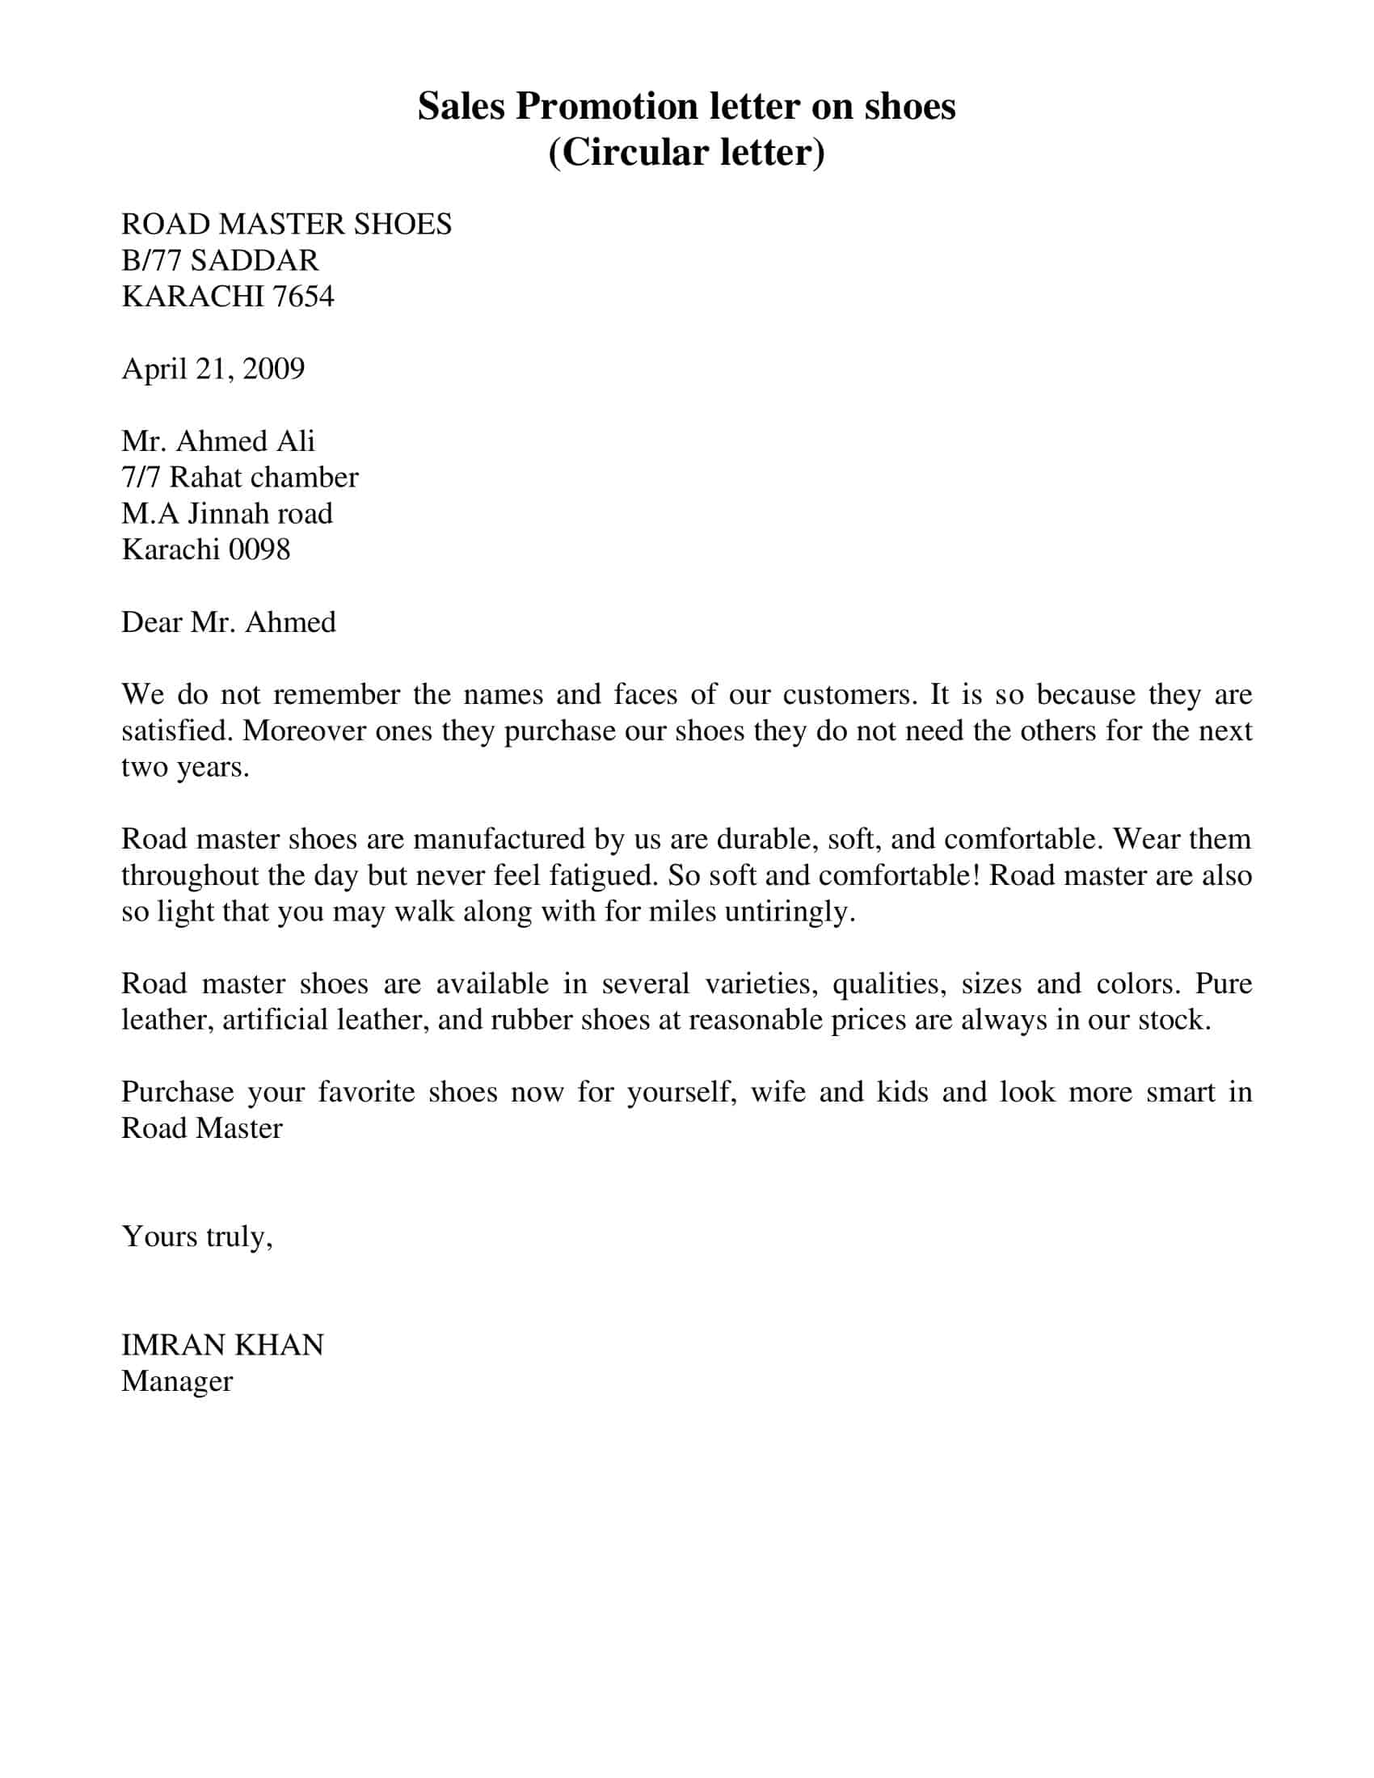

What Is Intra Office Communication?
Intra office communication refers to the exchange of information and ideas within an organization or company, among employees, teams, departments, and levels of management. It is a vital component of a company’s overall communication strategy, as it enables employees to share knowledge, collaborate, and make informed decisions. Intra office communication can take many forms, including face-to-face conversations, phone calls, emails, instant messaging, video conferencing, and even social media platforms.
Importance of Intra Office Communication
Intra office communication is essential for several reasons:
- Intra office communication helps to build trust and rapport among employees, which is crucial for effective teamwork and collaboration.
- It facilitates the exchange of information and ideas, which can lead to better decision-making and problem-solving.
- It helps to resolve conflicts and misunderstandings by providing a platform for employees to express their concerns and opinions.
- It promotes a sense of belonging and inclusivity among employees, which can lead to
increased job satisfaction and productivity.

Circulars
- Purpose: To convey information or instructions to a large group within the organization or public. It is a notice that has to be circulated.

Example 1:

Reliance Industries
MG Road , Mumbai
CIRCULAR
Date: 07 June 2026
This is to inform all employees that starting from 10 June 2026, office hours will be from 8:00 AM to 4:00 PM.

HR Manager

Notice and Agenda with Examples
Meaning and Importance of Notices
The day-to-day issues of the management of business organizations as well as their pressing problems are discussed in meetings of concerned executives. They are intimated about the day, date, time and place of the meeting and the points to be discussed in them. Such intimations in a written form are known as notices. Normally the guidelines of procedure of every organization clearly lay down the notice period needed for calling every kind of meeting including those of Governing Body, Executive Committee, Finance Committee. The person responsible for organizing such meetings should ensure that the notice is despatched to concerned executives or officers within this time.
The corporate bodies must follow the provisions of the Companies Act while despatching notices to be sent in connection with different types of meetings. They include board meetings, the statutory meeting, the annual general meeting, the extraordinary general meeting and so on. The secretary of the company must strictly adhere to the provisions regarding notices of such meetings.
The notice should be despatched to all those who are entitled to attend a given meeting. The day, date, time, place and business to be transacted should be stated in the notice. If the items of business to be transacted are limited in number, they can be stated in the notice itself. Otherwise, they must be listed in a separate sheet enclosed with the notice as an Annexure.
Notice of Meeting:
A general meeting must be called by giving not less than 21 days' notice in writing, but a shorter notice will suffice (a) in case of an Annual General Meeting, if all the members entitled to vote thereat so agree, and (b) in the case of any general meeting, if it is agreed to vote at the meeting.
According to section 172, notice of every general meeting must be given to:
(i) every member of the company
(ii) persons entitled to any shares on the death or insolvency of members
(iii) the auditor or auditors of the company.
Contents of Notice:
Every notice of a company meeting must specify the place and the day and hour of the meeting and also a statement of the business to be transacted thereat.
Every notice calling a meeting of a company which has a share capital or the articles of which provide for voting by proxy at the meeting must include a statement that a member entitled to attend and vote is entitled to appoint a proxy to attend and vote instead of himself, and that a proxy need not be a member.
Where any special business is transacted at the meeting, there must be annexed to the notice of the meeting an explanatory statement containing the following information:
(a) All material facts concerning each item of special business.
(b) Where any item of special business is according no approval to any document by the meeting, the time and place at which the document can be inspected.
(c) Where any item of special business relates to or affects any other company, the extent of shareholding interest in that other company of every director, the managing agent, secretaries and treasurers and the manager (if any) of the company, if such interest is not less than 20 per cent of the paid-up share capital of that other company.
Where, however, the notice of a meeting is given by advertisement in a newspaper, the explanatory statement need not be annexed to the notice, but it must be mentioned in the advertisement that the explanatory statement has been forwarded to the members of the company.
A notice is issued before a meeting. Generally the secretary of the company despatches a notice to all who are entitled to receive notices under the Act and by the Articles of the company. A notice convening a meeting contains the name of the company, the place, the date, the time and the business to be transacted thereat.

Notice Example -1
Arbuda Mills Ltd.
Rakhial,
Ahmedabad.
NOTICE
September 1, 2025
Notice is hereby given that a General Meeting of the Company will be held at the Company's Registered office on October 10, 2025 at 4-00 p.m. for the purpose of considering the company’s annual accounts and other general business.
By order of the Board,
Pranay Mehta
Secretary

GYAN VIKAS COLLEGE
(Accredited with ‘A’ Grade by NAAC)
Affiliated to Gujarat University
Kalavad Road, Rajkot – 360005, Gujarat
Phone: (0281) 2456789 | Email: info@gvcollege.ac.in | Website: www.gvcollege.ac.in
28th August 2025
NOTICE
Internal Examination
All students are informed that the Internal Examination will be held from 19th September to 26th September 2025. The detailed timetable will be displayed on the college notice board and the college website shortly.
Instructions for Students:
1. Arrive at least 15 minutes before the start of Exam
2. Carry your College ID Card and Admit Card without fail.
3. Strictly follow the examination rules.
All students are advised to check the timetable and prepare accordingly.
By Order
Mrs. S. K. Mehta
(Chairperson)
Examination Committee
Gyan Vikas College

AGENDA
Meaning and Importance of Agenda:
Agenda is a document that outlines the contents of a forthcoming meeting. It is usually sent along with the notice of the meeting.
Agenda is defined as an official list of business to be transacted during a particular meeting. The secretary works out its details in consultation with the chairman of the given organization. When a meeting is held, the business is generally taken up in the sequence in which it is stated in the agenda.
Sometimes the agenda is prepared after the circulation of the notice in order to enable the members to get included in the agenda any item that they would like to be discussed at the meeting. Occasionally, if the chairperson and the secretary do not want the members to know the items to be discussed, the agenda is not circulated.
Preparing Agenda is a very useful practice.
- If it is circulated in advance, it helps the members to come prepared for the meeting.
- Since agenda has a set order, it helps the chairperson to conduct the meeting smoothly.
- It ensures that only matters relevant to that particular meeting are discussed.
- It ensures that every point is properly taken up for discussion.
- It facilitates the preparation of the minutes.

Example:1
Star Commerce Chamber
Nehru Road
Rajkot
30th August 2025

AGENDA

The Agenda for the next HR meeting to be held on Monday, 1st September 2025, at 11:00 a.m. in the Conference Room, Administrative Block are:
- Reading of Minutes
- Confirmation of Minutes
- Matters Arising from Minutes
- Main Items
- Overtime of Employees
- Transport after Overtime
- Any Other Business
- Date of Next Meeting

(Signature)
Meera Shah
Secretary

Notice with Agenda Example:

Reliance Industries
MG Road, Mumbai.
NOTICE and AGENDA
July 1, 2025
Notice is hereby given that 25th annual General Meeting of the Company will be held at the Company's at 4-00 p.m., on October 10, 2025 at NMAMC, BKC. The Agenda for the meeting is :
- To read the minutes of 24th AGM.
- To confirm the minutes of the last General Meeting.
- To read the Annual General Report for the year 2025.
- To declare a dividend for the financial year ended March 31, 25.
- To declare new projects of the company.
- To appoint Auditors and to fix their remuneration.
- To transact any other business with the permission of the Chair.

By order of the Board,
Pranay Mehta
(Secretary)

MINUTES OF MEETING

What are meeting minutes?

Meeting minutes are the written record of a meeting or hearing. Minutes are usually structured and formal so that they can be shared after the meeting and serve as historical documents in the future. For those who could not attend the meeting, minutes bring them up to speed. Minutes also offer accountability to action items that were discussed during the meeting. More importantly, if an organization enters into any sort of legal situation, minutes serve as an official record proving due diligence, ethics, and bylaw compliance.

Who takes meeting minutes?

The secretary most often takes meeting minutes. Nonprofits, government entities, schools, public companies, and trade unions are usually required to record official meeting minutes. However, many other companies also use meeting minutes to maintain an official record.

How to write meeting minutes

The style and content of meeting minutes will vary depending on the organization and how it’s structured. Regardless, you should always include the basics, like date, time, and participants. But many organizations will also benefit from having other, optional items like supplementary documents and action items. Read on to find out what to include in your meeting minutes.

